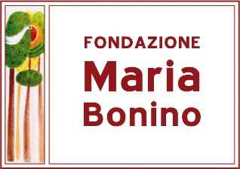
Fondazione Maria Bonino
Via Maria Bonino, 12 Borgata Gallo
13821 Camandona (BI)
www.fondazionemariabonino.it

The applications for project support must necessarily contain:
1. Illustration of the context in which you intend to operate (country and locality, social and health situation, politics, ethnic groups, language, population, etc.)
2. Objectives of the project
3. Categories of people who benefit from the project
4. Proposed activities and time schedule
5. Expenditure budget divided by items
6. Expected results
7. Expected monitoring and commitment to a periodic report
8. Any partners / collaborations with government institutions and / or local authorities / co-financiers
9. Organization profile
10. Project leader and local manager: name (s), surname (s) and contacts

The application must not contain more than 5000 words.
For projects approved and therefore financially supported in whole or in part, the following must be submitted:
1. a six-monthly report: activities, results obtained, any difficulties, accompanied by photographs and specific stories or cases useful for communicating the project
2. an annual report: like the previous one but accompanied by numerical indicators for the results obtained (example: number of patients reached, number of children healed and discharged, number of families taken in charge, etc.)
3. an annual cost statement
4. specify how the support for the project by the Maria Bonino Foundation was made known

Paolo Bonino
Presidente Fondazione Maria Bonino

